Disability Support Services 

The University of Limerick welcomes students whose educational experience has been impacted due to disability, significant ongoing illness, mental health condition or specific learning difficulty. The Disability Support Services team are here to support students as they transition to university life!

How to find us:

Our offices are located on the ground floor of the Glucksman library – along the right-hand side of the main library information area just opposite the main entrance and gates.

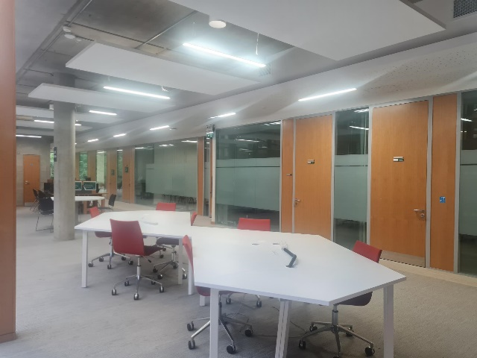

You can get more information about our services and our team from our website: www.ul.ie/student-affairs/disability-services. You can also email us directly at DisabilityServices@ul.ie.

How to register:

The University is part of the DARE (Disability Access Route to Education) entry route.

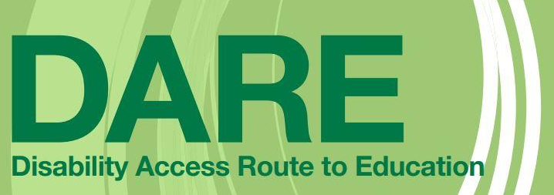
If you are a DARE applicant you don’t need to do anything - we will be in touch with you to arrange for a needs assessment – please look out for emails from DisabilityServices@ul.ie!!

If you are not a DARE applicant you can still register with us! We work with all students enrolled in the University of Limerick; there is certain additional information/documentation we will need from you for full registration that will be explained to you. You can start the registration process through the student portal.

Once you complete this registration, we will email you for any additional information or to arrange a needs assessment meeting. Remember – look out for emails from Disabilityservices@ul.ie
Frequently Asked Questions:

Will my personal information be shared with lecturers or anyone else in the university?

Your personal or medical information will not be shared with anyone outside of the members of the Disability Services team without your direct consent. Any information about you will be kept completely confidential and secure.

What is a Needs Assessment?
Your needs assessment meeting is an opportunity for you to discuss what supports you might need. The meeting usually lasts from 15 to 30 minutes and can be held online via Teams or in person at our offices in the library.

The purpose of the needs assessment is to:
- Create a support plan that works for you
- check your personal details and gather relevant background information
- discuss the demands of your course
- discuss any assistive technology or training needs you might have
- discuss any reasonable accommodations, including exam accommodations, that you might need
- Answer any questions you may have

What are Reasonable Accommodations?
The reasonable accommodations a student has are determined on a case-by-case basis during a needs assessment and are different for every student depending on what they need. An example of these might be extra time or a smaller venue for exams, learning support, note-taking support for lectures, access to occupational therapy, or a range of assistive technology supports.
What is a LENS (Learning and Educational Needs Summary)?
A LENS (Learning Educational Needs Summary) lists the reasonable accommodations that a student requires. This is generated following the needs assessment and a link to this will be sent to the student and to their module leaders via email from DisabilityServices@ul.ie. It is important to note that the LENS includes no medical information and that the link is only accessible to the student and their module leaders. The link is here: Learning Educational Needs Summary but will only work once the needs assessment is complete.
This link is really important! If you have any exam accommodations you will be in a different location to that noted on your main UL exam timetable – your LENS will have the correct venue details for your exams.

The DSS team fully understands how challenging starting university can sometimes be – we are here to help!
If you have any questions at all make sure to contact us at disabilityservices@ul.ie.

